MST40 Abstract Title (Arial, bold, 18pt)

Name1 A. Surname ¹, Name2 B. Surname ^{1,2}, Name3 C. Surname ^{3*} (Times New Roman, 10pt)
¹ Affiliation1 including Department, Faculty, University, City or State, Postal code, Country (Times New Roman, 10pt)
² Affiliation2 including Department, Faculty, University, City or State, Postal code, Country
³ Affiliation3 including Department, Faculty, University, City or State, Postal code, Country
Presenter E-mail address: mst@microscopythailand.org (Times New Roman, 10pt)
*Corresponding Author E-mail address: microscopy@microscopythailand.org (Times New Roman, 10pt)

Abstract
An abstract for MST40 international conference will be published in the conference proceedings. All abstracts should convey the novelty or importance of microscopy and microanalysis. A wide range of fields are included in the scope of the journal, for instance, Materials Science, Chemistry, Physics, Biology, Anatomy, Microbiology, etc. Please do not use abbreviations in the abstract. Please note that the length of the extended abstract including figures and tables, must not exceed 2 pages. Figures and tables should be prepared using the suggested text box below (by copying and pasting in the text box). To avoid the formatting errors, please prepare each figure including labels as one image file. A referencing format is described in the “References” section. Please prepare the abstract file using the Microsoft Word version 2010 or above. (Times New Roman 10)

Keywords: please provide up to five keywords, separated by semi-colon (;) (Times New Roman, 10pt)

References:
1. First Initial. Surname, Title, Journal abbreviation, Volume, pages (Year).
2. S. Shuman, Structure mechanism and evolution of the mRNA capping apparatus, Prog. Nucleic Acid Res. Mol. Biol., Vol. 66, 1-40 (2000).
3. First Initial. Surname, First Initial. Surname, Title, Journal abbreviation, Volume, pages (Year).
4. P. Chomczynski, N. Sacchi, Single-step method of RNA isolation by acid guanidinium thiocyanate-phenol-chloroform extraction, Anal. Biochem., Vol. 162, 156-159 (1987).
5. First Initial. Surname, Book Title, Edition, Publisher, City published, Page(s) (Year).
6. J. Sambrook, E.F. Fitsch, T. Maniatis, Molecular Cloning: A Laboratory Manual, 2nd Edition, Cold Spring Harbor Press, New York, 18-25 (1989).

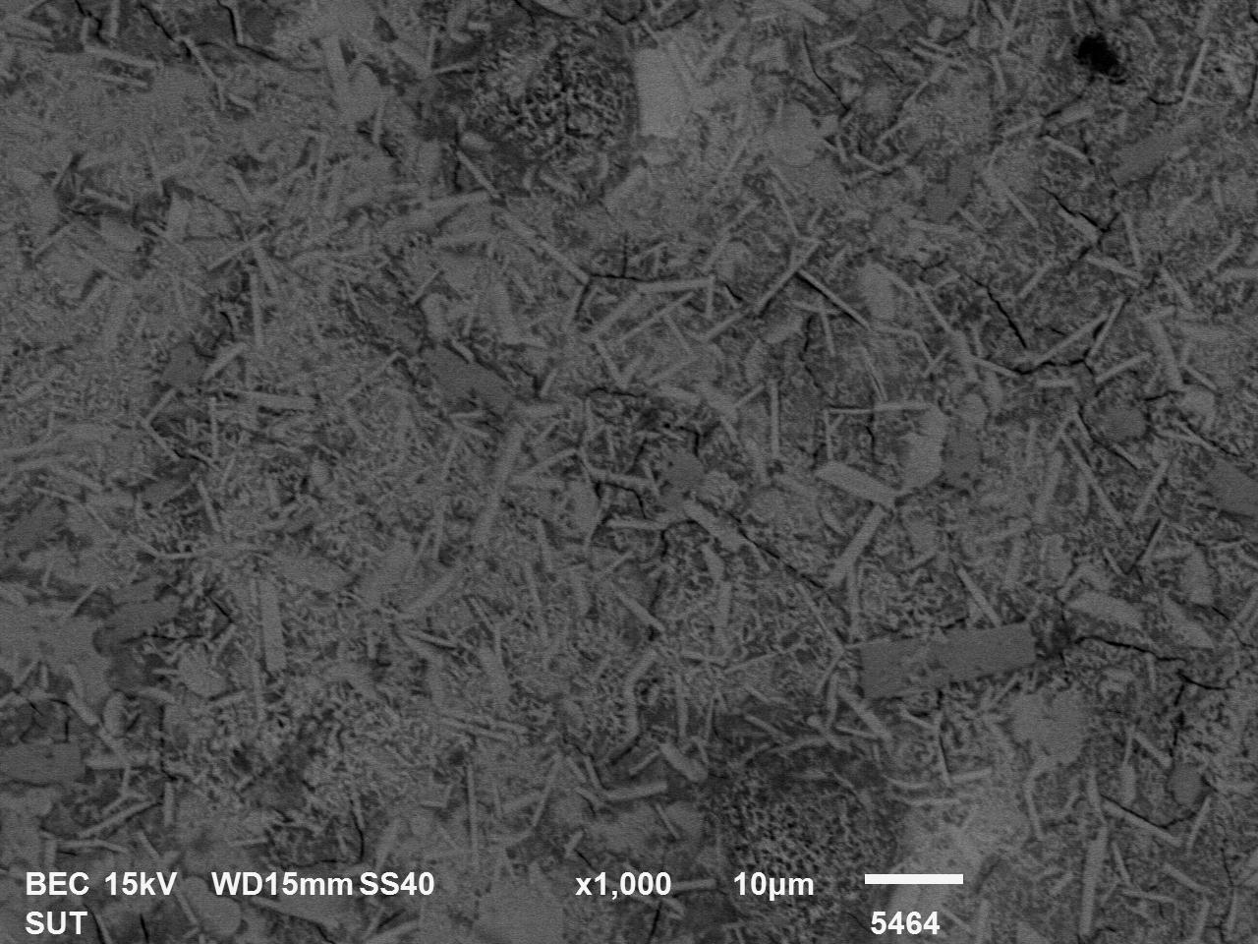

Figure 1. Caption (Times New Roman, 9pt, justified). Please use ‘text box’ for inserting figures. Figures may also be inserted into a single column.
Table 1. Concentration characteristics Caption (Times New Roman, 9pt, justified).

Concentration  (wt.%) | Current  (mA) | Factor | Ratio (%)
0.000 | 5.95 | 0.73 | 3.33
0.025 | 8.45 | 0.84 | 5.67
0.050 | 6.40 | 0.74 | 3.73
0.075 | 6.69 | 0.67 | 3.43
0.100 | 6.14 | 0.46 | 1.63
1.000 | 2.50 | 0.39 | 0.35

